Exhibit: Demonstration, Model, or Display
A demonstration or model describes how or why something works. A display reveals details about the topic.

Assessed on the rubric:

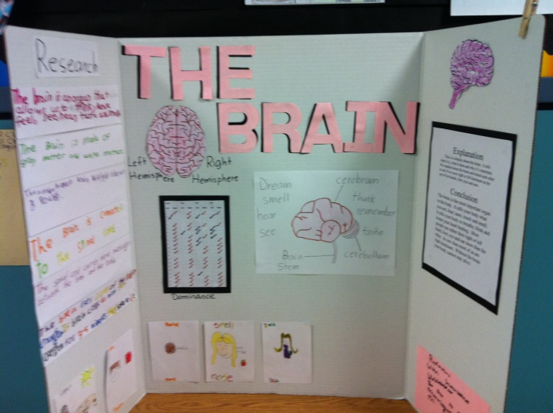
- Title
- Research Report
  - Exhibit Explanation
  - Conclusions
  - References and Acknowledgements

EXAMPLES:
The Brain
The Life of Bees
Hurricanes
What are Gluten Free Foods?
Orcas
How Do Magnetic Trains Work?
It’s a long Way to the Top! (food chains / webs)
What is a Solar Eclipse?

Experiment
An experiment is a fair test designed to answer a question to which you do not already know the answer

Assessed on the rubric:
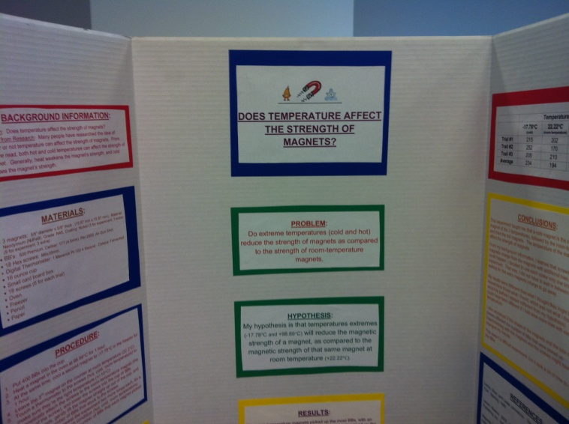
  - Title of Experiment
  - Problem / Question
  - Definitions
  - Hypothesis
  - Background Information
  - Experimental Materials
  - Experimental Procedure
  - Results (Data)
  - Conclusion
  - References and Acknowledgements

EXAMPLES:
Testable Questions:
How does temperature affect the strength of magnets?
How does freezing popcorn kernels affect the number that pop?

Comparative Questions:
Which battery band will last the longest?
Which diaper brand holds the most liquid?
Detergent War! (Which detergent gets the stains out best?)

- Prohibited from display: (The following types of objects will be removed before judging)
  - Living or preserved plants or animals
  - Food
  - Liquids
  - Glass
  - Sharp objects
  - Soil, dirt, waste products

